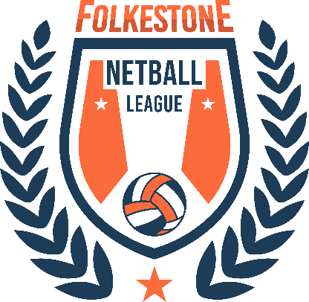

Un-Affiliated Players Disclaimer Form

I, …………………………………………………………………………………………………. (Full Name) am registering to join the Back to Netball sessions run by Folkestone Netball League (FNL).
I understand it is strongly advised by FNL to be a member of England Netball or to have personal insurance. However, at this time I am not affiliated with England Netball and I accept that I am taking part in these sessions at my own risk.
I understand that neither FNL, England Netball or other players shall not be liable for any injury I sustain whilst taking part in the sessions.
I understand that any possessions I take to the venue are my own responsibility and any damage or loss will not be covered by FNL, England Netball, the venue or other participants.
I have read and agree to abide by the Code of Conduct of FNL which can be found at https://www.folkestonenetballleague.com/ and rules as set out by England Netball at https://www.englandnetball.co.uk/

Signed:………………………………………………………………
Date:………………………………………………………………….

.

